**Problem Statement For Analysis Of Variance:**

1. **Impact of Training Programs on Employee Performance:**

**Problem Statement:**

A company offers three different training programs to its employees. The HR department wants to determine if there is a significant difference in employee performance scores (measured before and after training) across these three training programs. Use ANOVA to analyze whether the training program affects the improvement in performance.

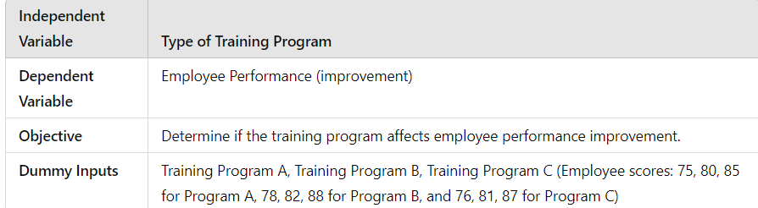

1. **Effect of Diet Type on Weight Loss:**

**Problem Statement:**

A fitness clinic assigns clients to three different diet plans (low-carb, low-fat, and balanced diet). The clinic wants to analyze whether there is a significant difference in the average weight loss among individuals following each diet. Use ANOVA to test if diet type significantly affects weight loss.

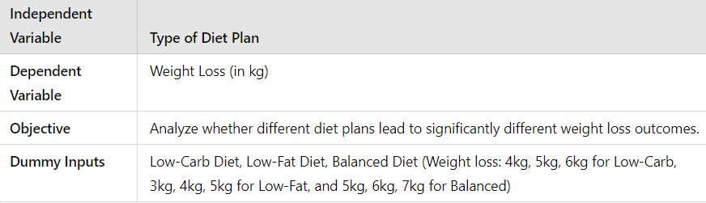

**3. Comparison of Advertising Strategies on Sales Performance:**

**Problem Statement:**

A company runs three types of advertising campaigns (TV, social media, and print) and measures sales revenue generated by each. The marketing team needs to determine if the type of advertising strategy significantly impacts sales performance. Perform ANOVA to see if the mean sales revenue differs across the campaigns.

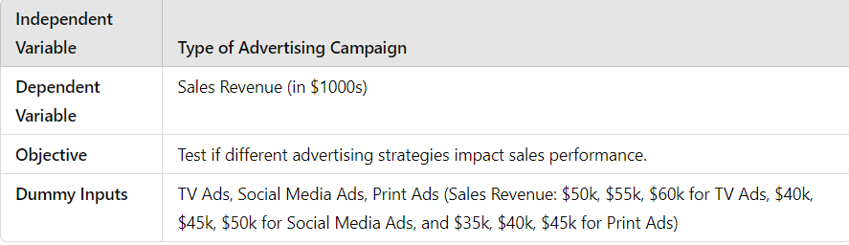

**4. Influence of Teaching Methods on Student Test Scores:**

**Problem Statement:** An educational institution uses three different teaching methods (traditional lecture, interactive learning, and online learning) for a mathematics course. The institution wants to determine if there is a significant difference in student test scores based on the teaching method used. Conduct ANOVA to see if teaching methods influence test scores.



**5. Effect of Temperature and Humidity on Product Quality:**

**Problem Statement:** A manufacturing process is tested under three different temperature conditions, and the quality of the product is measured. The quality control team is interested in finding out if the variations in temperature lead to significant differences in product quality. Use ANOVA to analyze the effect of temperature conditions on the average product quality.

